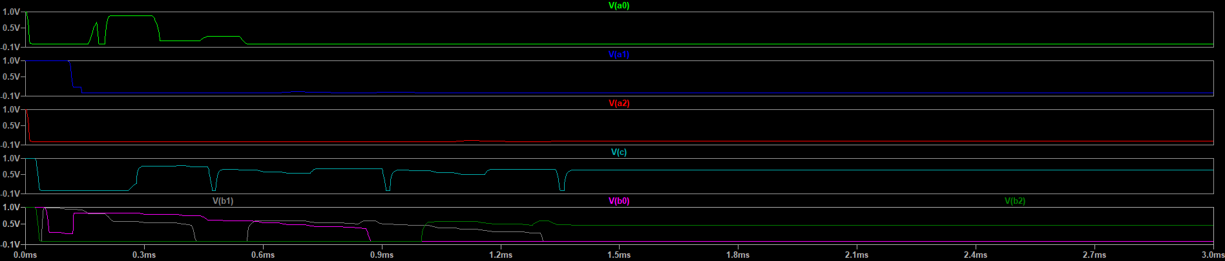

Exact adder output

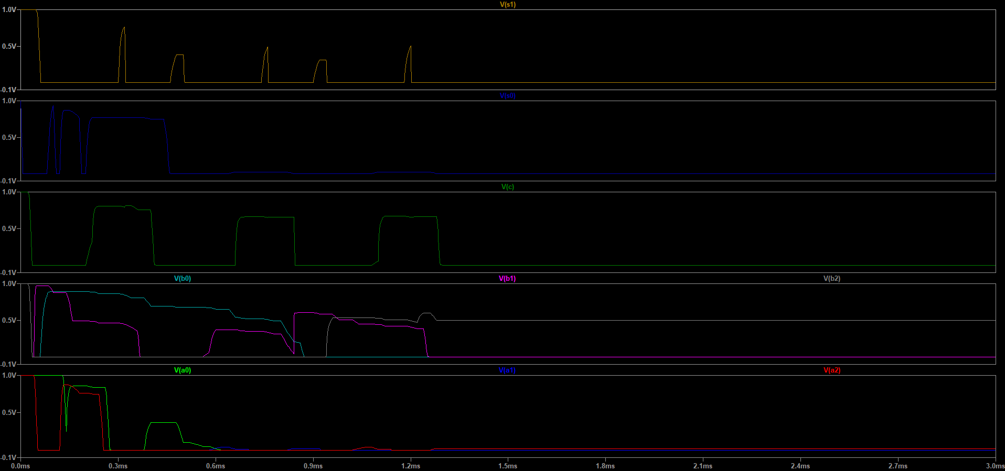

Approx Adder output